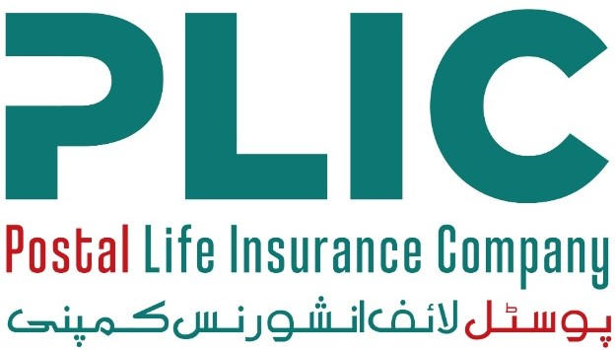

CAREER OPPORTUNITIES

Postal Life Insurance Company Limited (PLICL), established under the Insurance Ordinance, 2000, is one of Pakistan’s oldest and most trusted life insurance providers. As a state-owned entity, PLICL has a long-standing reputation for financial stability, customer-centric services and nationwide accessibility. The Company operates through an extensive network ensuring quality life insurance products to the individuals and families across both urban and rural areas of the country. The Company continues to modernize its operations through digital transformation, improved customer service standards, and strengthened compliance with regulatory requirements set by the Securities and Exchange Commission of Pakistan (SECP).

To support its ongoing growth and to further enhance organizational performance, PLICL is inviting applications from dynamic, qualified, and results-driven professionals for the following positions: -
Sl. No. | Position Title | No. of Posts | Maximum Age | Minimum Qualification Requirements | Minimum Experience  Requirements | Location
1. | Chief Financial Officer (CFO) | 1 | 55 years | Should be a member of a recognized body of professional accountants OR Fellow or Associate member of the Casualty Actuarial Society or the Institute of Actuaries in England or Society of Actuaries in the USA. | Minimum 5 years of post-qualification experience, preferably in an insurance company. | Islamabad
2. | Head of Internal Audit (HoIA) | 1 | 55 years | Should be a member of a recognized body of professional accountants (preferably CA). Certified Internal Auditor or Certified Fraud Examiner or Certified Internal Control Auditor will also be considered provided he/she has relevant experience. | In case of candidate with preferred qualification, required experience will be 10 years with at least 5 years at a senior position, preferably in a medium to large Insurance Company / Financial Institution. In case of a Certified Internal Auditor or Certified Fraud Examiner or Certified Internal Control Auditor, minimum experience required will be 15 years with at least 5 years at a senior position, preferably in a medium to large Insurance Company / Financial Institution. Should have experience of Audit or Compliance function. | Islamabad
3. | Head of Human Resources | 1 | 50 years | - Master’s degree in Human Resource Management, Business Administration, or a related field from an HEC – recognized University.  - Preferably with additional certifications in HR (e.g., SHRM, CIPD, CHRP). | - At least 12 to 15 years of progressive HR experience, including 5 years in a senior leadership role.  - Demonstrated expertise in strategic HR management, organizational development, and regulatory compliance.  - Experience in the insurance or financial services sector will be an added advantage. | Islamabad
4. | Senior Manager (Human Resources) | 1 | 45 years | - Master’s degree in Human Resource Management, Public Administration, Business Administration, or equivalent from an HEC – recognized Institution.  - HR certification (preferred but not mandatory). | - 7 to 10 years of relevant HR experience with at least 2 to 3 years in a managerial role.  - Strong knowledge of HR operations, recruitment, compensation & benefits, employee relations, and performance management systems.  - Experience in regulated industries (insurance, banking) is desirable. | Islamabad
5. | Manager Claim | 1 | 45 years | - Master’s degree from HEC - recognized University.  - As a special case graduate may be considered provided he/she has exceptional experience and has achieved a record of accomplishments and successful performance of their duties. | - 5 year’s experience in Life Insurance Claims and Operations of a Insurance Company.  - Knowledge of SECP regulations and requirements in relevant operations is must.  - Certification in Life Insurance will be preferred. | Lahore
6. | Assistant Human Resources Officer | 1 | 30 years | - Bachelor’s degree in Human Resource Management, Business Administration, or related discipline from HEC – recognized University.  - Master’s degree (preferred but not essential). | - 1 to 2 years of relevant HR experience.  - Fresh graduates with internships in HR or administrative roles may be considered.  - Familiarity with HR systems, recordkeeping, and recruitment support functions will be advantageous. | Islamabad

- Candidates who meet the above criteria may apply online by selecting the relevant “Position Title” on our website at www.plic.com.pk/careers. Please ensure that the “Position Title” is clearly mentioned in the subject line of the email. The last date for submission of applications is 02nd December, 2025.

- Applications submitted through post or by hand will not be accepted.

PLICL is an Equal Opportunity Employer. We strongly encourage female candidates to apply.

Human Resources Department,
Postal Life Insurance Company Limited,
051-9192950

Head Office: 2nd Floor, Postal Staff College, G-8/4, Islamabad.
Phone: 051- 9262815

